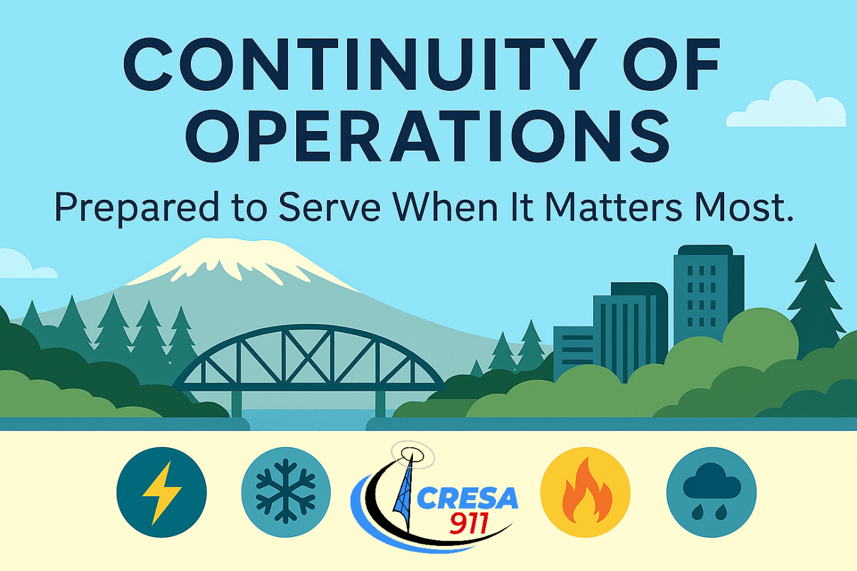
COOP Training Guide
June 2025

Contents
Phase 0: Foundations and Understanding 3
Phase 1: Jurisdiction Engagement and Pre-Planning 4
Phase 2: Plan Template Review 5
Phase 3: Department Working Sessions 6
Phase 4: COOP Review and Gaps 7
Phase 5: Final Edits and Approval 8

Phase 0: Foundations and Understanding
Objective: Understand COOP fundamentals and the structure of the city you're supporting.
Recommended Actions:
- Review FEMA Continuity Guidance Circular (CGC) and IS-1300.
- Review Clark Regional COOP Program (plan templates, supporting documentation, meeting handouts)
- Familiarize yourself with the city’s organizational chart, essential services, and interdependencies.
Key Takeaways
- COOP ensures critical functions continue during disruption.
- Each city will require a tailored approaches due to size and complexity.
Key Players
- CRESA EM
Reference Links
- Continuity Guidance Circular
- IS-1300.A: Introduction to Continuity

Phase 1: Jurisdiction Engagement and Pre-Planning
Objective: Make introduction to jurisdiction and prepare departments for COOP planning.
Recommended Actions:
- City Management Engagement
  - Meet with City Manager’s Office, Deputy City Managers, and key executive leadership (in most cases this includes department heads) to deliver the COOP overview presentation.
  - Clarify expectations for department participation, emphasize the role of leadership support.
  - Confirm messaging, approach, and any city-specific nuances (big projects that the city is working on, any department specific deadlines – like budget)
- Department Level Engagement
  - Send out follow up emails to department heads to schedule department COOP meeting.
Key Takeaways
- Relationship-building is crucial to gain cooperation and accuracy.
- Department engagement must be scaled to the city’s complexity and size.
- Be flexible! Work with their schedules and be prepared to pivot to another department if there is more availability.

Key Players
- City Management / Leadership
- Department Heads / Leadership

Deliverables
- Follow up email to department heads for meeting scheduling
- Meeting notes and planning considerations (if applicable)

Phase 2: Plan Template Review
Objective: Review and revise each department’s COOP plan in advance, using available information to pre-fill as much content as possible and familiarize yourself with the department’s structure and essential functions before the first working session.
Recommended Actions:
- Locate and Review Existing Department Materials: Gather the most recent version of the department’s COOP plan (if it exists).
  - Review prior drafts, planning notes, or documents from past planning cycles.
  - Explore city websites or internal platforms for department mission, services, structure, and leadership.
- Populate the COOP Template in Advance:
  - Use any existing documents, notes from leadership meetings, org charts, and public materials to fill in sections of the template (e.g., department overview, basic staffing info, primary responsibilities).
  - Where possible, make reasonable assumptions or placeholders for department functions, dependencies, or locations that can be confirmed during the department meeting.
- Identify Gaps and Department-Specific Needs
  - Highlight sections requiring confirmation or clarification (e.g., essential functions, RTOs, staffing rosters).
  - Identify any department-specific risks, interdependencies, or operational notes that may need discussion.
Key Takeaways:
- This phase is preparatory — it ensures you're informed before meetings begin.
- Pre-filled templates help focus department discussions and build facilitator credibility.
Key Players:
- COOP Facilitator
Deliverables:
- A partially completed COOP template for each department, with as much verified or placeholder information as possible.
- A list of pre-identified questions or gaps to guide the upcoming department meeting.

Phase 3: Department Working Sessions
Objective: Facilitate working sessions to review each department’s COOP plan in real time, validate essential functions, and assign follow-up actions.
Recommended Actions:
- Confirm or Update Department Points of Contact (POCs):
  - Department heads typically serve as initial POCs but may delegate after the first meeting.
- Conduct COOP Working Session:
  - Meet individually with each department
  - Walk through COOP template and capture any follow up actions items that need to be completed (there is always homework after these meetings)
  - Adjust meeting participants based on department size:
    - For small departments (fewer than 10 people), include the entire team.
    - For larger departments (more than 10 people), request key leads or managers attend and ensure internal message relay afterward.
- Action Items and Next Steps
  - Identify information gaps, data needed, or follow-up tasks (e.g., updated staff rosters, resource lists, contact lists).
  - Assign action items with clear owners and timelines.
  - If necessary, schedule a follow-up meeting to finalize the plan and confirm any unresolved items.
  - Note any required modifications to the standard COOP template based on department structure, services, or complexities.
Key Takeaways:
- COOP planning is collaborative and department-owned — your role is to guide and support.
- Working directly in the template during meetings makes the process efficient and keeps it grounded in real-world operations.
- Every meeting will likely result in follow-up actions (“homework”) to close information gaps but ultimately it is the department’s responsibility — with City Management oversight — to complete their plan.
Key Players:
- Department Directors and department leadership or key leads (for larger departments)
- COOP Facilitator (you)
Deliverables:
- Draft department COOP plan with live edits captured during the session.
- Documented action items with responsible owners and deadlines (if applicable).
- Scheduled follow-up meetings (if required).
- Summary of any gaps, dependencies, or unresolved issues, flagged for citywide COOP plan coordination and leadership awareness.

Phase 4: COOP Review and Gaps
Objective: Finalize department plans, support departments through follow-up, and begin preparing for citywide plan review and future exercises. This is the most flexible phase, with departments progressing at different paces.
Recommended Actions:
- Incorporate updates and follow-up items received from departments.
  - Ensure consistency in format and structure across plans.
  - Confirm all essential sections are completed and validated by department leadership.
- Manage Variable Department Timelines:
  - This is the most time-intensive and variable phase. Some departments may quickly reach this point, while others will require additional support.
  - Use this time to:
    - Send follow-up emails to departments that haven’t submitted updates.
    - Offer assistance and check in regularly.
    - Keep City Management informed and engaged to support accountability.
- Prepare for Review and Engagement Activities:
  - Begin planning for internal leadership-level review meetings to evaluate plan progress, identify cross-department gaps, and flag any critical interdependencies.
  - For departments with solid drafts, consider identifying opportunities to test plans through discussion-based exercises.
  - Departments that complete their drafts may proceed to Phase 5 (Final Edits and Approval), even if others are still in progress.
- Note on Continuity of Government (COG) Planning:
  - Do not begin formal COG planning until all departments have reached at least Phase 3.
  - COG requires a citywide view of continuity priorities, which can only be informed once departments have clearly defined their essential functions and leadership roles.
  - Until then, track potential COG-related notes (e.g., succession gaps, unclear delegations) for future development.
Key Takeaways:
- This is the most flexible phase — departments will move at different speeds.
- Regular follow-up is critical to maintain progress and support slower-moving departments.
- Plans can be finalized as drafts and approved with the understanding that updates will continue annually.
- COG planning should not begin until department-level work is well established.
Key Players:
- Department Directors and COOP POCs
- Senior City Leadership (City Manager’s Office, Legal, HR)
- COOP Facilitator (you)

Deliverables:
- Running list of status by department
- Summary of interdepartmental gaps or issues
- Leadership review notes (if held during this phase)

Phase 5: Final Edits and Approval
Objective: Incorporate final feedback, finalize COOP plan components, and coordinate approvals — while recognizing that plans will continue to evolve through annual updates and future exercises.
Recommended Actions:
- Incorporate Final Feedback and Edits:
  - Apply any outstanding changes from department leadership or internal reviews.
  - For departments that have completed their drafts and addressed major gaps, prepare the plan for approval as-is — even if minor refinements will occur during next year’s update.
- Coordinate Plan Approval Process:
  - Submit finalized plan to department leadership for sign-off or formal acknowledgement.
  - Work with City Management or Legal to determine what level of approval (e.g., City Manager signature, internal resolution) is needed.
- Support Distribution and Plan Access:
  - Encourage departments to determine how they will store and share their finalized COOP plan internally.
  - Offer guidance on storage options, access permissions, and records management best practices.
  - Request that CRESA receive a copy of each finalized COOP plan for regional coordination and continuity tracking, while emphasizing that distribution decisions are ultimately the responsibility of each department and city leadership.
- Plan for Training, Exercises, and Annual Updates:
  - Begin identifying opportunities for tabletop exercises to validate finalized plans.
  - Create a list of improvement ideas that can be addressed during next year’s update cycle.
  - Establish a tracking sheet for future edits, feedback, and lessons learned.
Key Takeaways:
- Not all departments will finish at the same time — support those that are ready to finalize their plans while continuing to engage others.
- The COOP plan is a living document — practical use and periodic updates matter more than perfection.
- Post-approval engagement through training and exercises is critical to long-term effectiveness.
- Annual updates will ensure the plan remains aligned with evolving city operations.
Key Players:
- Department Directors and COOP POCs
- Senior City Leadership (as needed for sign-off)
- COOP Facilitator (you)
- City Records or IT staff (for optional storage support)
Deliverables:
- Final signed or acknowledged department COOP plans
- Support materials for plan storage and access (if applicable)
- Annual maintenance/update schedule

